
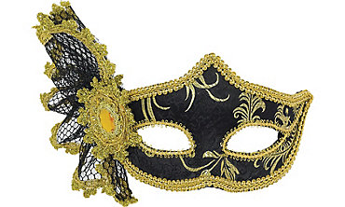
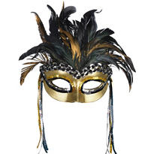
Celebrate the gift of life by Unmasking

The Mystery of Organ Donation
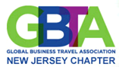
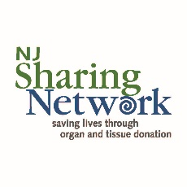
Proceeds benefit

and

SCHOLARSHIP FUND
Join us for a Masquerade Gala - black tie optional
featuring
Silent and Live Auction plus raffle prizes

Cocktail Reception, Buffet Dinner and Three Hours Open Bar

DJ & Dancing
Date: Friday, December 8th, 2017
Time: 6:30 PM to 10:00 PM
Where: Madison Hotel
One Convent Road
Morristown, NJ 07069
www.themadisonhotel.com
Price: $125 per person
Sponsorship Opportunities Still Available

http://njbta.org/content.php?page=2017_Gala_Sponsorship_Opportunities
RSVP: by November 30th
Purchase your sponsorships or tickets at:
https://njbta.starchapter.com/catalog.php?cat=4
Sponsored by:
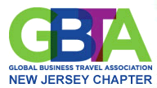
For more information visit our website: http://njbta.org
NJ Sharing Network’s mission is to save and enhance lives through
the miracle of organ and tissue donation and transplantation

